

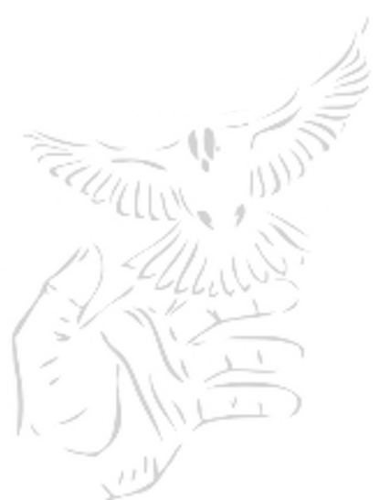
Internet Access for Prisoners
In a just world, there are no prisons. A truly just society doesn't need them.
We aren't there yet and so we work for reforms that not only make the agonizing ordeal of incarceration less damaging, demeaning and destructive but that move us a bit closer to the goal we share: the elimination of prison as a social institution.
Among the greatest challenges we face is struggling against the torturous isolation incarcerated people endure. Not only is it destructive to those people but it robs the rest of society of the contribution and benefits that full communication with them provides and blocks our attempts to struggle against the ravages of imprisonment.
At May First/People Link, we believe that the Internet is the most powerful communications network developed by humanity. We view it as a social movement, comprised of over a billion people, battering the social and national enclosures that limit communication among us at a historic movement when communication among the world's people is more important than ever.
The change Internet communication has brought to our lives is a right we all have. Our collaboration, mutual support and enthusiastic spreading of Internet technology has made possible a sharing of information that has moved our world forward while repeatedly mitigating the impact of the vicious repression and oppression the ruling class visits upon us.
(over)

Internet Access for Prisoners
In a just world, there are no prisons. A truly just society doesn't need them.
We aren't there yet and so we work for reforms that not only make the agonizing ordeal of incarceration less damaging, demeaning and destructive but that move us a bit closer to the goal we share: the elimination of prison as a social institution.
Among the greatest challenges we face is struggling against the torturous isolation incarcerated people endure. Not only is it destructive to those people but it robs the rest of society of the contribution and benefits that full communication with them provides and blocks our attempts to struggle against the ravages of imprisonment.
At May First/People Link, we believe that the Internet is the most powerful communications network developed by humanity. We view it as a social movement, comprised of over a billion people, battering the social and national enclosures that limit communication among us at a historic movement when communication among the world's people is more important than ever.
The change Internet communication has brought to our lives is a right we all have. Our collaboration, mutual support and enthusiastic spreading of Internet technology has made possible a sharing of information that has moved our world forward while repeatedly mitigating the impact of the vicious repression and oppression the ruling class visits upon us.
(over)

Prisoners have the right to that communication and no where is the potential power of the Internet more obvious than behind the walls of these barbaric institutions whose numbers are growing in this society.
With full Internet access:
- the abuses behind prison walls could be immediately reported, assistance prisoners need in so many areas could be facilitated and a fuller picture of the abuse incarceration itself represents would be immediately available
- prisoners could reach out to each other and to all of us, organize, inform and get badly needed support
- information of all kinds -- now available through controlled television and limited reading material -- would flood into prisons
- educational programs, now becoming more scarce by the day, could be facilitated and improved
- on-line cameras would serve to protect incarcerated people from the abuse, oppression, loneliness and isolation they face while educating all of us about a way of life that is usually hidden from us
- people behind bars could join us in the flood of creative, probing and informative exchange of information, writing, art, photography and video that has served such a powerful social, artistic and political role
- and we all could reach through those walls and organize...as a people united despite the attempts to divide us.
We believe that full Internet access for all people is an absolute right. We believe that right must be enjoyed by people in prisons and jails. We believe any progressive movement should make that a priority.
We support that right. We think everyone at this conference should. And we're ready to work with anyone to make that support, and the realizing of that right, a reality.
May First/People Link + http://mayfirst.org/

Prisoners have the right to that communication and no where is the potential power of the Internet more obvious than behind the walls of these barbaric institutions whose numbers are growing in this society.
With full Internet access:
- the abuses behind prison walls could be immediately reported, assistance prisoners need in so many areas could be facilitated and a fuller picture of the abuse incarceration itself represents would be immediately available
- prisoners could reach out to each other and to all of us, organize, inform and get badly needed support
- information of all kinds -- now available through controlled television and limited reading material -- would flood into prisons
- educational programs, now becoming more scarce by the day, could be facilitated and improved
- on-line cameras would serve to protect incarcerated people from the abuse, oppression, loneliness and isolation they face while educating all of us about a way of life that is usually hidden from us
- people behind bars could join us in the flood of creative, probing and informative exchange of information, writing, art, photography and video that has served such a powerful social, artistic and political role
- and we all could reach through those walls and organize...as a people united despite the attempts to divide us.
We believe that full Internet access for all people is an absolute right. We believe that right must be enjoyed by people in prisons and jails. We believe any progressive movement should make that a priority.
We support that right. We think everyone at this conference should. And we're ready to work with anyone to make that support, and the realizing of that right, a reality.
May First/People Link + http://mayfirst.org/

